 | 

RF Deflectors for Combiner and Damping Rings

D. Alesini¹ and F. Marcellini¹

- LNF-INFN, Frascati, Italy

Abstract

Traveling wave and standing wave RF deflectors are used in different linear or circular accelerators. In the paper a summary of the study and design of RF deflectors for the CTF3 Combiner Ring and Delay Loop and for TESLA Damping Ring is presented. Electromagnetic characteristics of both standing wave and traveling wave structures are examined. Some issues related to the beam dynamics in the Combiner Ring and in the Delay Loop, considering the beam loading effect in the deflectors, are presented. Concerning the TESLA Damping Ring, different injection/extraction schemes are considered.
1 Introduction

The most relevant characteristic of RF deflectors is to deflect bunches of a given train differently or to deflect the head and the tail of a given bunch with opposite sign. The first characteristics is used, for example, in CTF3/CLIC schemes where RF deflectors are used to recombine different trains [1,3-5], while the second characteristic is used, for example, in the CRAB cavities of colliders or to characterize the longitudinal and transverse phase space at the end of an injector [2].
The main differences between traveling wave (TW) or standing wave (SW) RF deflectors are reported in Table I. All this characteristics are consequence of the different bandwidth between the two types of devices.
In this paper we illustrate different applications of RF deflectors. In particular in Section 2 we describe the CTF3 Combiner Ring RF deflectors illustrating the main design characteristics, the measurement results and the beam loading effects on the transverse beam dynamics. In Section 3 we illustrate the CTF3 Delay Loop RF deflectors design with some considerations concerning the beam loading effects on the transverse beam dynamics. Finally, in Section 4, we discuss the proposal recently made to inject or extract bunches in the TESLA Damping Ring.

Table I: Comparison between TW and SW RF deflectors.
 | SW | TW
Efficiency per unit length  (Deflection vs, RF Power) | HIGH | LOW
Filling time | PROPORTIONAL TO THE QUALITY FACTOR: GENERALLY SLOW. | PROPORTIONAL TO THE GROUP VELOCITY AND STRUCTURE LENGTH: GENERALLY FAST
Deflecting field vs. number of cells n | SCALES AS $\sqrt{n}$ | SCALES AS $n\left(1−e^{−αn}\right)$ WITH $α=\text{attenuation}$
Maximum number of cells | THE MAXIMUM NUMBER OF CELLS IS LIMITED TO ABOUT 10 BECAUSE OF MODE OVERLAPPING | IN PRINCIPLE THERE ARE NO LIMITATIONS TO THE NUMBER OF CELLS.
Circulator | A CIRCULATOR IS GENERALLY NEEDED TO PROTECT THE KLYSTRON FROM REFLECTED POWER. | •CIRCULATOR NOT NECESSARY.
Temperature sensitivity | NECESSITY OF AN AUTOMATIC TUNING SYSTEM OR OF A VERY GOOD TEMPERATURE STABILIZATION TO MAINTAIN THE CAVITY ON RESONANCE DURING OPERATION | LESS TEMPERATURE SENSITIVITY.

2 RF Deflectors for CTF3 Combiner Ring

The CTF3 (CLIC Test Facility 3) [1] is the third test facility of the CLIC (Compact Linear Collider) project [3-5]. The CTF3 main goal is to prove the feasibility of the 30 GHz RF power production in a long (140 ns) pulse by using the bunch recombination technique. The conceptual layout of CTF3 is shown in Fig. 1. The frequency multiplication by the novel bunch interleaving technique is one of the most important issues to be tested. In CTF3 a long (1.4 $μs$) train of 20 cm spaced short bunches (Drive Beam) is converted into a short (140 ns) train of 2 cm spaced bunches. In the first stage the pulse is compressed by a factor of 2 by using a transverse RF deflector at 1.499 GHz and a 42 m circumference Delay Loop (DL). An 84 m circumference Combiner Ring (CR) is used in the second stage to furtherly compress the pulse by a factor of five [6]. This will be achieved by means of two RF deflectors working at 2.998 GHz already constructed [7,8] and successfully tested in the CTF3 Preliminary phase [9,10].
The main parameters of CTF3 CR are reported in Table II.
The process of bunch train compression in the CR is illustrated in Fig. 2. The efficiency required for the RF deflectors can be easily achieved by scaling already existing TW or SW structures. On the contrary, the most demanding issues are those related to the beam dynamics, including the beam loading effects on the fundamental deflecting mode. Strong beam loading effects can, in fact, affect both the beam transverse dimensions and the beam transport and, as a consequence, the efficiency of the power conversion at 30 GHz. From this point of view it has been chosen to build TW RF deflectors since wake fields can leave the structure faster due to the lower filling time.
The main RF Deflector parameters are reported in Table III.

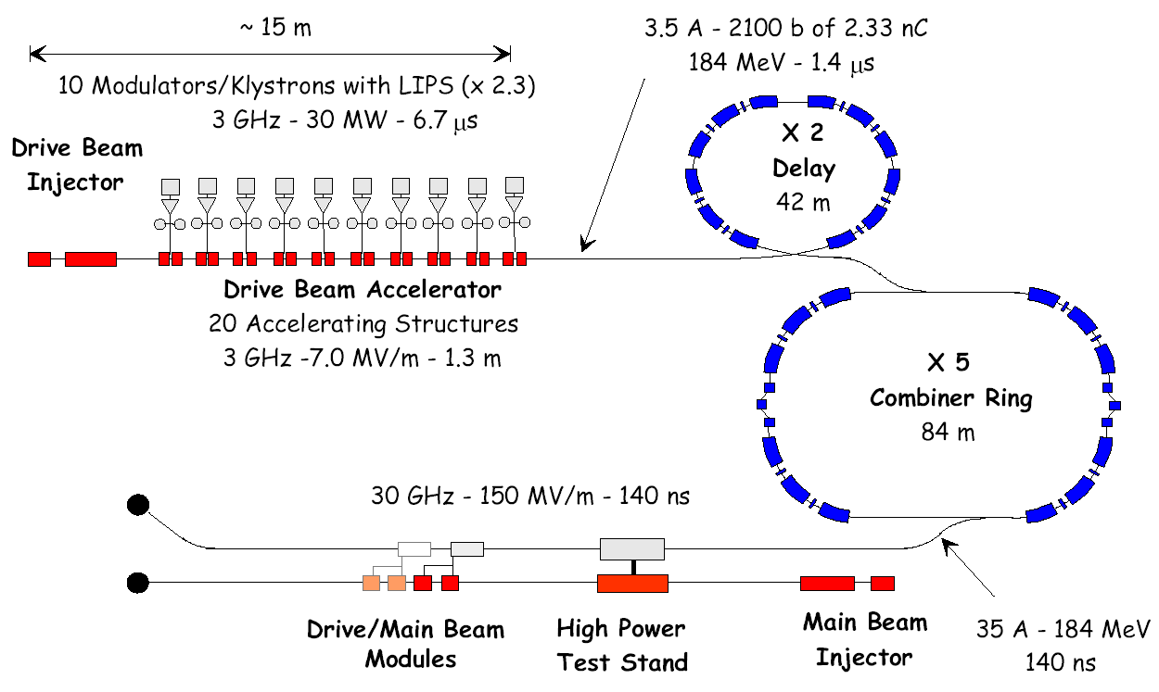
Fig. 1: Conceptual layout of CTF3.

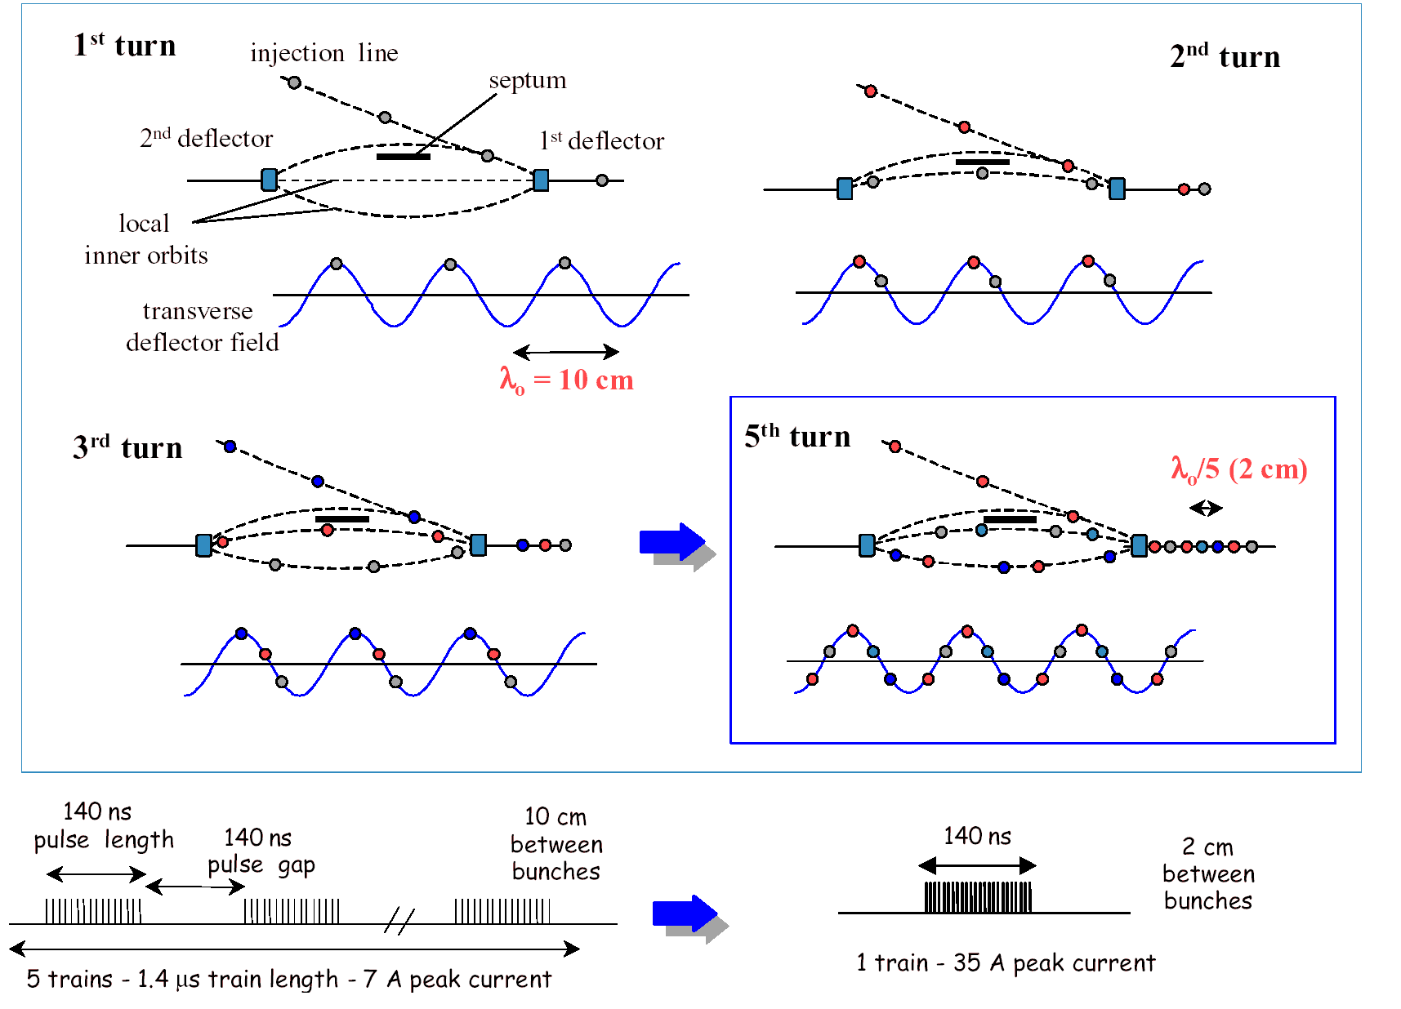
Fig. 2: Sketch of the bunch frequency multiplication in the CTF3 CR.

Table II: Main CTF3 parameters at the injection/extraction of the CR.
Energy (E) |  | 180 [MeV]
Circumference length (L) |  | 84 m
Bunch charge (Q_{b}) |  | 2.33 [nC]
Bunch length ($σ_{z}$) |  | 1.5-2.5 [mm]
Beam emittance ($ε$) |  | ∼ 0.4 [mm mrad]
Number of bunches per pulse (N_{b}) |  | 2100
Inj. | Pulse duration ($τ_{{\text{CR}}_{\text{inj}}}$) | 1.36 [$μ$s]
Inj. | Number of trains per pulse (N_{pinj}) | 5
Inj. | Bunch separation ($τ_{B}$) | 0.33 [ns]
Extr. | Pulse duration ($τ_{{\text{CR}}_{\text{extr}}}$) | 140 [ns]
Extr. | Number of trains per pulse (N_{pextr}) | 1
Extr. | Bunch separation ($τ_{A}$) | 0.067 [ns]

Table III: Combiner ring RF deflector parameters.
Frequency (f) | 2.99855 [GHz]
Cell length (D) | 33.33 [mm]
Cell radius (b) | 56.01 [mm]
Iris internal radius (a) | 21.43 [mm]
Iris thickness (t) | 9.53 [mm]
Number of active cells (N_{c}) | 10
Phase advance per cell ($βD$) | 2$π$/3
Deflector length (L) | 33 [cm]
Group velocity (v_{g}/c) | -0.0237
Filling time ($τ_{F}$) | 47 [ns]
Shunt impedance per unit length (r_{s}) | 18.1 [M$Ω$/m]
r_{s}/Q | 1425 $Ω$/m
Input power (P_{in}) | 2 MW
Deflection ($φ_{D}$) | 5 [mrad]

2.1 RF Deflectors design and measurements

The design of the CTF3 RF deflectors [8] has been done scaling to the CTF3 working frequency (2.99855 GHz) the dimensions of CERN RF separators [11] with a reduced number of cells. These are disk-loaded backward waveguides working in the 2π/3 EH₁₁ hybrid mode [12] already optimized for beam deflection. The final 10 cells structure is shown in Fig. 3. The dimensions of each cell (sketched in Fig. 4a), reported in Table IV, have been optimized by simulating the structure with the electromagnetic code MAFIA [13]. The 2π/3 EH₁₁ mode dipole degeneration of the two orthogonal polarities, has been removed by inserting 2 longitudinal rods crossing off-axis the cells (just like the CERN separators) as shown in Fig. 4b. The simulated and measured dispersion curves of a stack of 8 cells (+2 half cells) before soldering the structure are shown in Fig. 5a and 5b. The coupler has been simulated with HFSS and the simulated and measured reflection coefficient (S₁₁) at the device input port is reported in Fig.6. Both measured curves (dispersion and reflection coefficient) are in good agreement with simulations and design requirements.
The deflectors have been made on OHFC high quality copper using hard soldering (brazing) technique well mastered in production processes of S band accelerating structures. For semplicity reasons it has been decided to avoid a tuning system of the cells. The correct frequency and field phase advance has been obtained by performing different sets of measurements on prototypes and by carefully controlling the machining and soldering procedure.

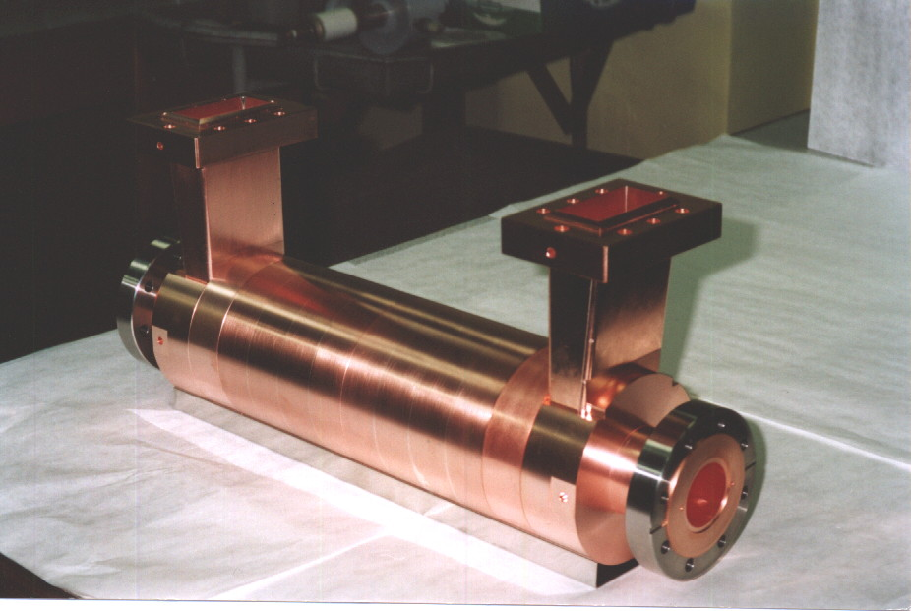
Fig. 3: CTF3 RF deflector.

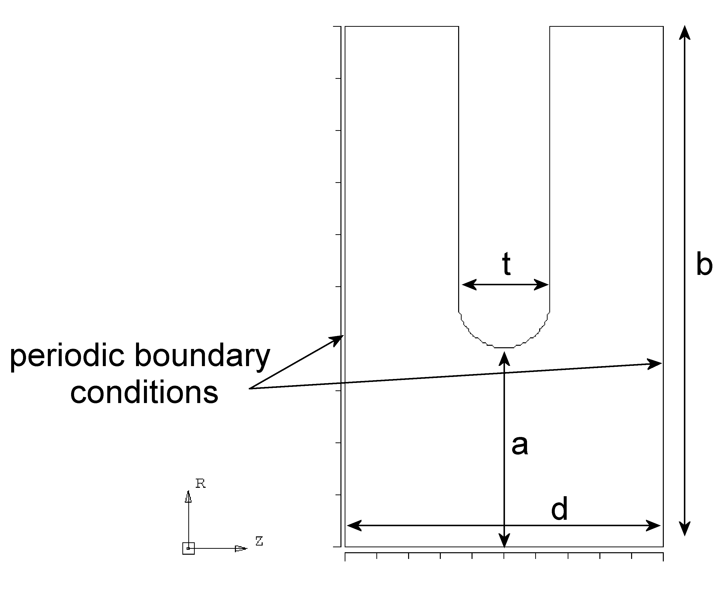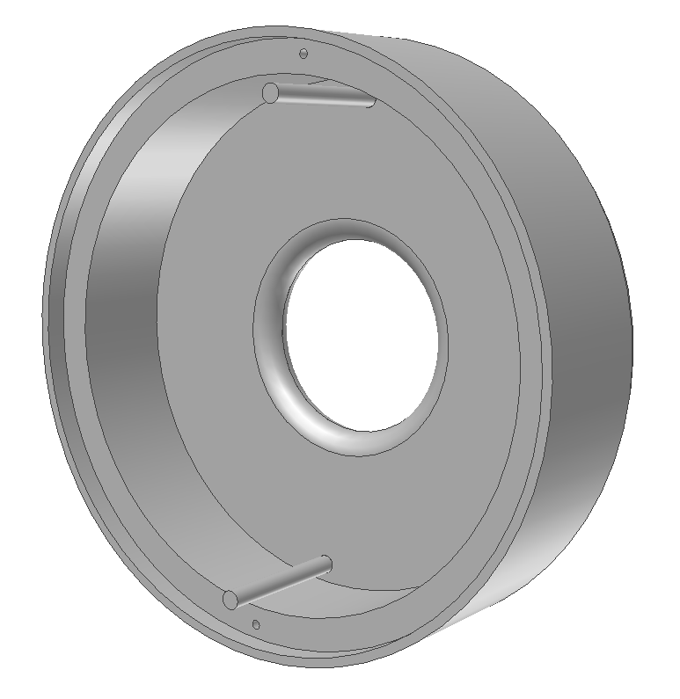
(a)
(b)
Fig. 4: sketch of the single cell profiles
(a)
(b)
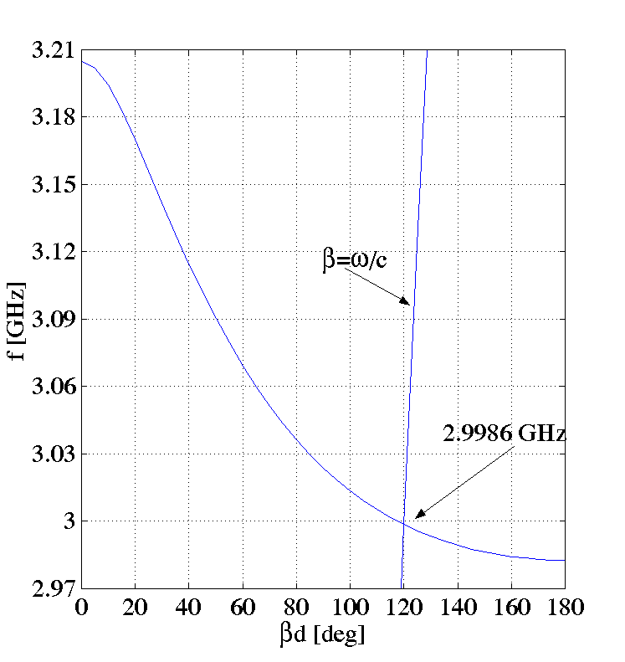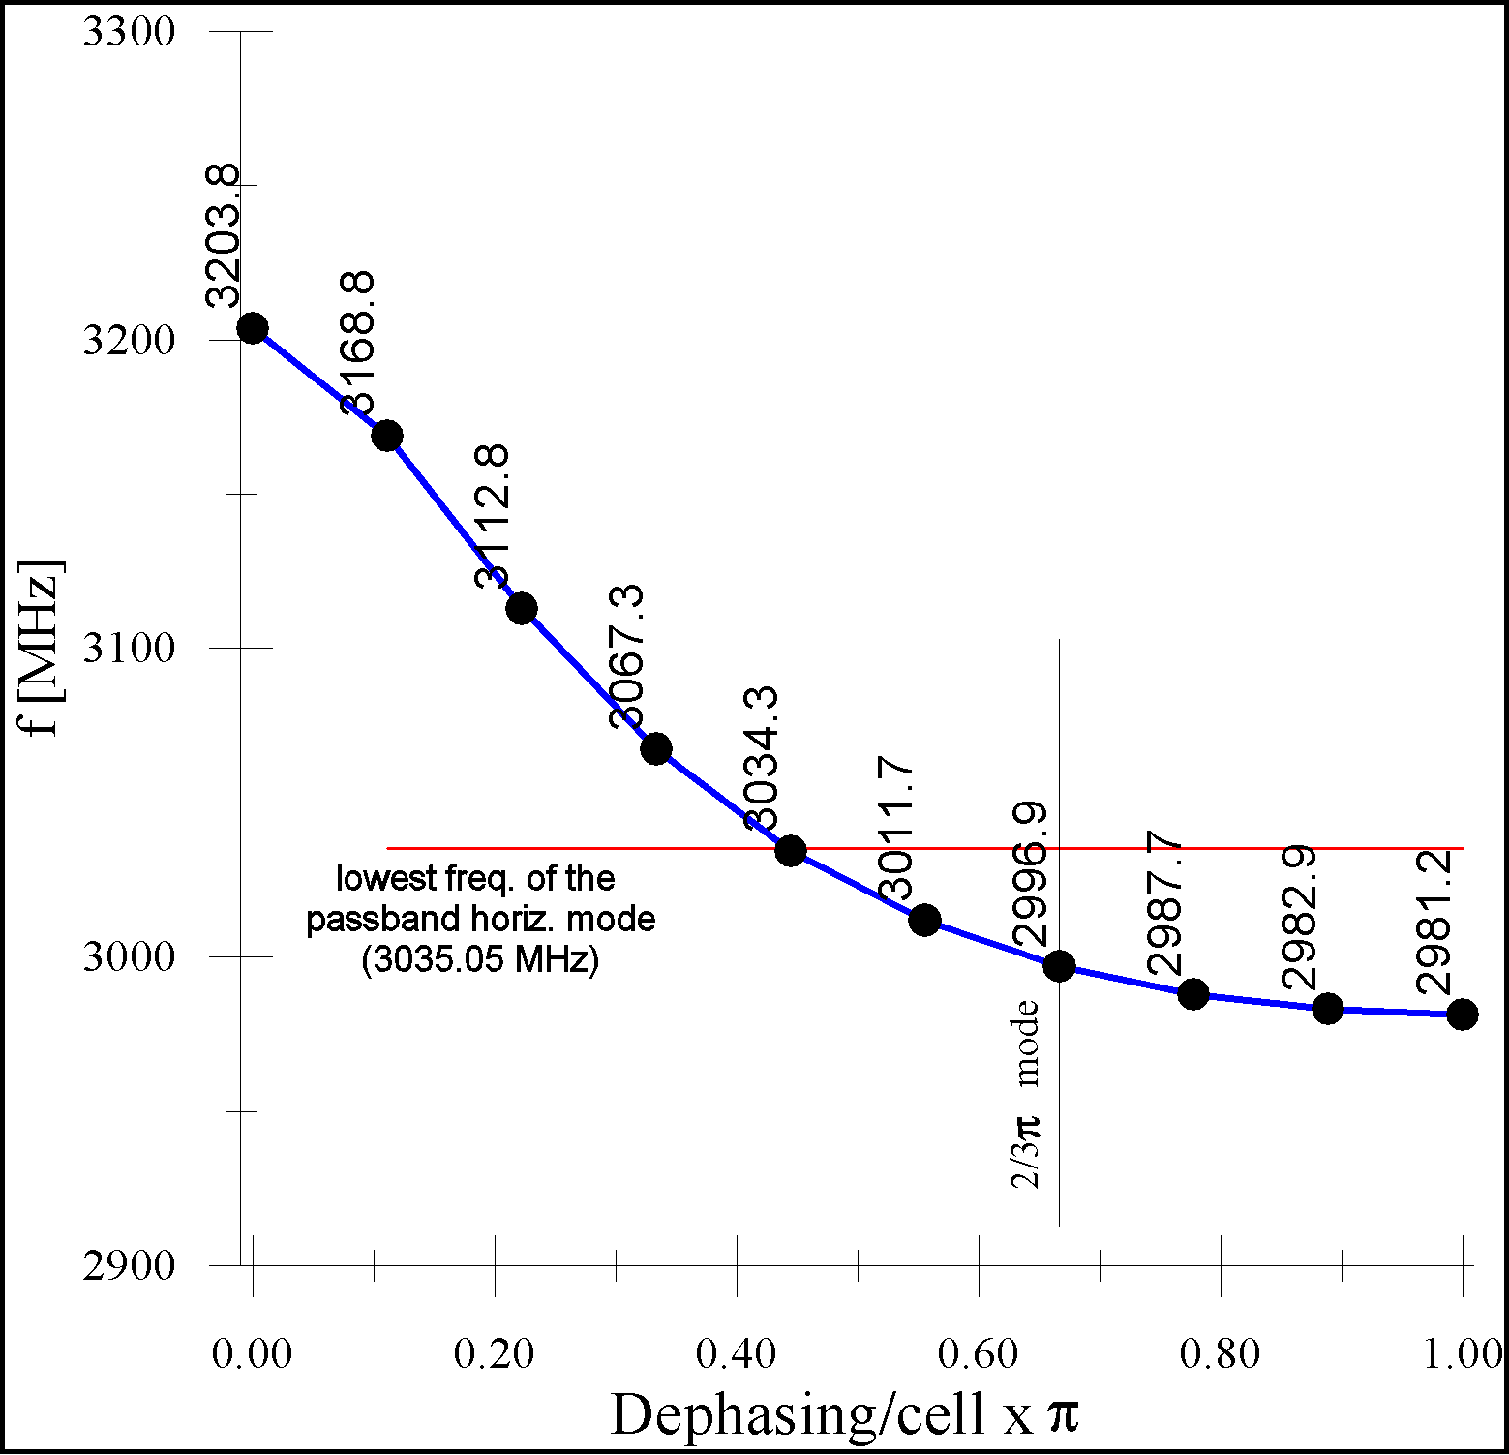
Fig. 5: dispersion curve of the deflecting mode obtained by MAFIA (a) and measured (b).
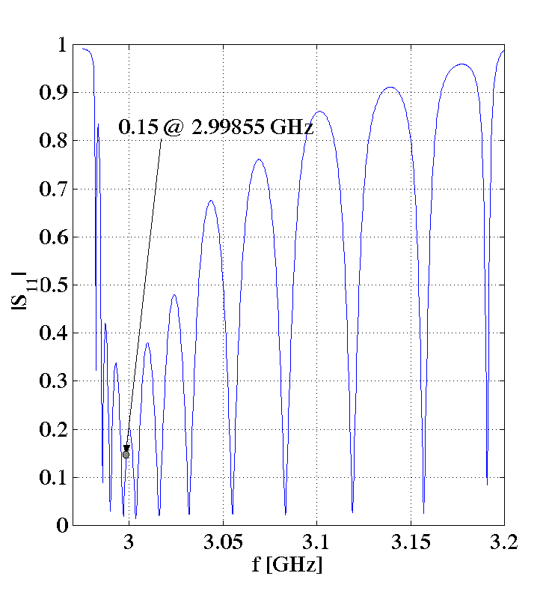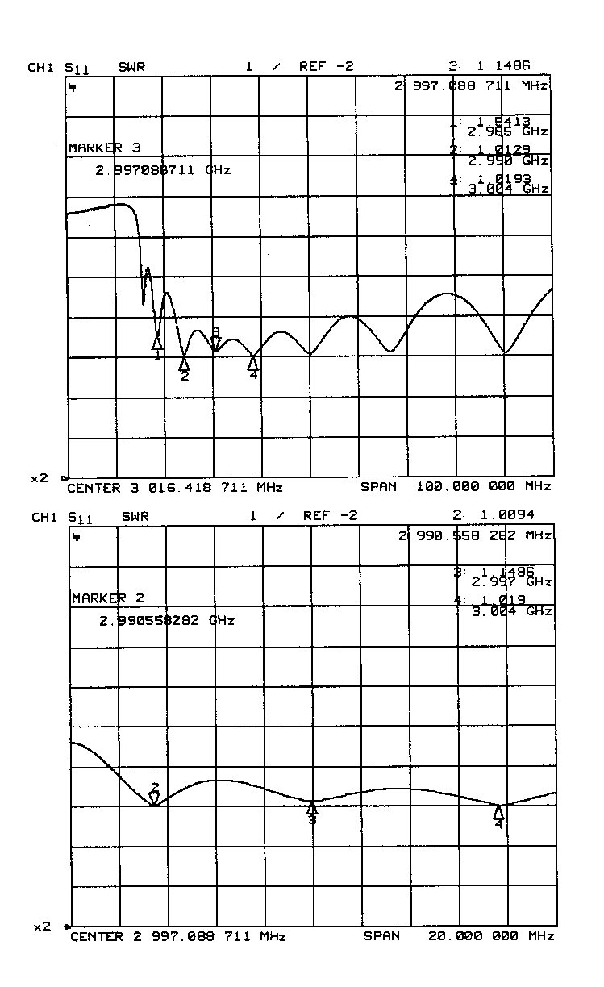
(a)
(b)
Fig. 5: reflection coefficient at the input port of the deflector as a function of frequency: (a) simulated; (b) measured

Table IV: final dimensions of the cell and RF deflectors parameters.
Final dimensions of the cells | a = 21.43 mm
Final dimensions of the cells | b = 56.01 mm
Final dimensions of the cells | d = 33.33 mm
Final dimensions of the cells | t = 9.53 mm
RF deflector parameters | f=2.9986 [GHz]
RF deflector parameters | v_{g}=-0.0237*c
RF deflector parameters | R/Q=1460 [Ω/m]

2.2 Effect of the beam loading in the RF Deflectors

The impact of the RF deflectors beam loading on the transverse beam dynamics of the CTF3 Combiner Ring as been studied in detail in ref. [14].
To evaluate the beam loading effects one has to consider both the interaction between the travelling charges and the transverse electric field (beam loading in phase) and between the travelling charges and the longitudinal electric field E_{z} (beam loading $\text{90}°$ out of phase).
The first contribution is similar to the standard beam loading in a LINAC accelerating section with the exception that, in this case, is the transverse component of the bunch velocity that couples with the EH₁₁ E field. The deflection spread along the train can be estimated obtaining a quite small value in the CTF3 case.
The second contribution is of more concern because in the CR the bunch pattern is such that, at a certain time, the deflector will be crossed by bunch trains off axis and with a phase separation of 2$π$/5 generating a mutual perturbation mainly through the out of phase wake.
In [14] a general expression for the single passage wake field has been obtained. It is shown that the general expression can be simplified applying a linearization of the RF deflector dispersion curve over either a limited or an unlimited frequency range. Comparison of different models has shown that a simple wake field formula can be safely applied to describe multi-bunch multi-turn wake field effects. The dedicated tracking code (sketched in Fig. 6) based on the simplest wake model has revealed that:

- the beam emittance growth due to the wake field in the RF deflectors is negligible if the trains are injected perfectly on axis. As example in Fig. 7a the positions and angles of the bunches with respect to the nominal orbit taken at the 1st deflector output at the end of the merging process without considering injection errors are reported. In Fig 7b the corresponding plot in the phase space;
- in case of injection errors the final emittance growth depends strongly on the betatron phase advance between the RF deflectors. For the worst phase advance values the emittance magnification factor may exceed 100. Instead, for the nominal phase advance $K1→K2$of $\text{260}°$ the emittance growth is close to its minimum. As example in Fig 9 it has been reported the average invariant with the relative error bars for the possible injection error shows in Fig. 8. In Fig 4 the ratios between the output (maximum and average) Courant-Snyder invariants and the initial one in the case of an injection error caused by a pure displacement of 1 mm and for various values of the betatron ring phase advance are reported;
- simulations taking into account the finite bunch length show that the scenario does not change for the central part of the bunches with respect to the case of zero bunch length. However, for some particular injection errors, the bunch tails can contribute to the increase of the total transverse bunch emittances.

The effects of the beam loading in the RF deflectors on the beam transverse phase space are considered tolerable, as long as the betatron phase advance between the kickers is close to the optimum value ($\text{260}°±\text{10}°$), the injection position and angle are not too large (${Δx}_{\text{in}}≤1\text{mm},Δx'_{\text{in}}≤0\text{.}7\text{mrad}$) and the bunches are short enough ($σ_{z}≤3\text{mm}$)
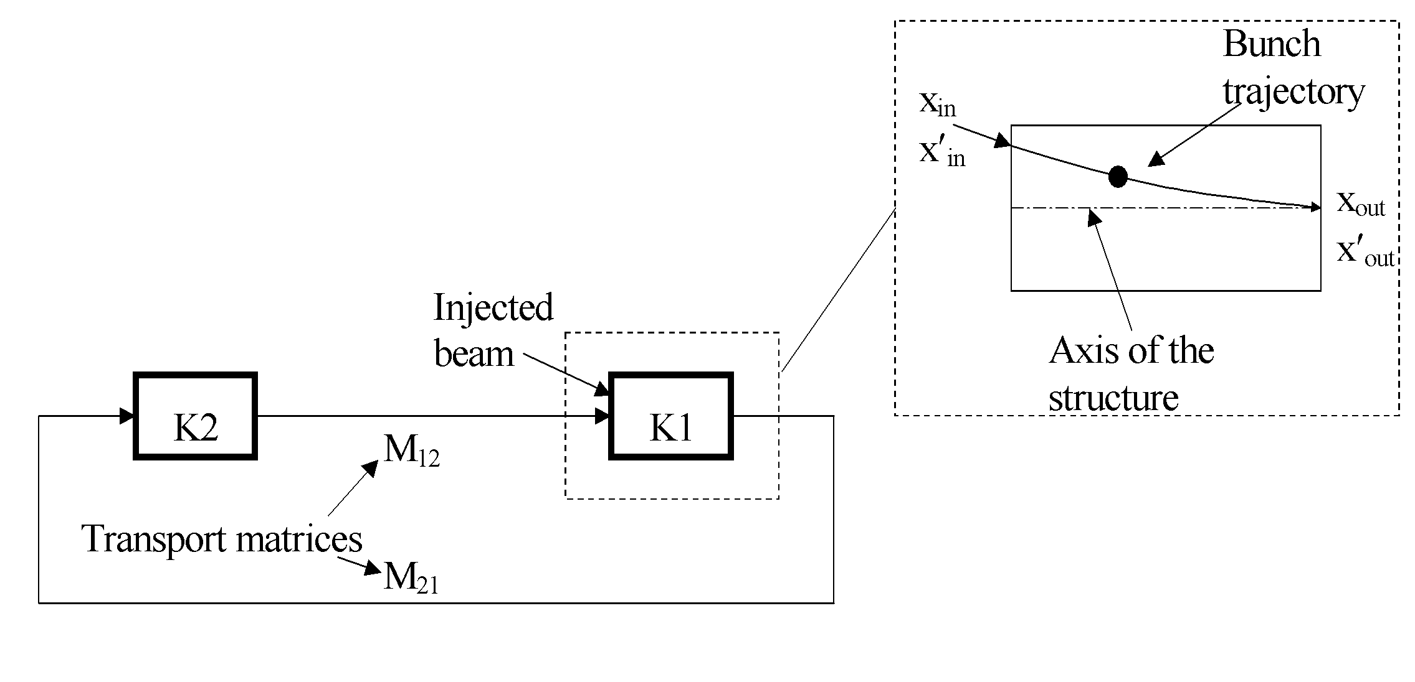
Fig. 6: Tracking code scheme.

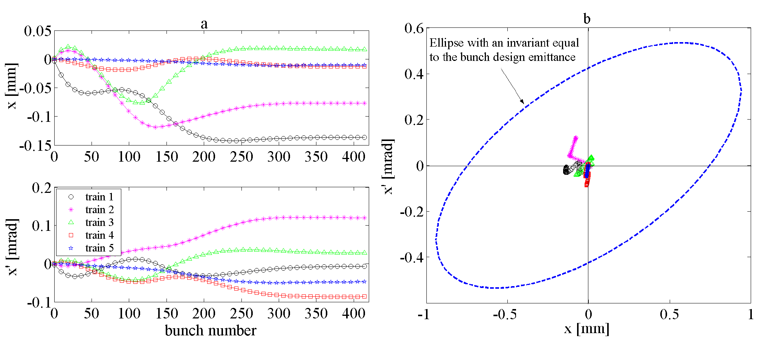
Fig. 7: Positions and angles of the bunches with respect to the nominal orbit taken at the 1st deflector output at the end of the merging process (a) and plot in the phase space (b).

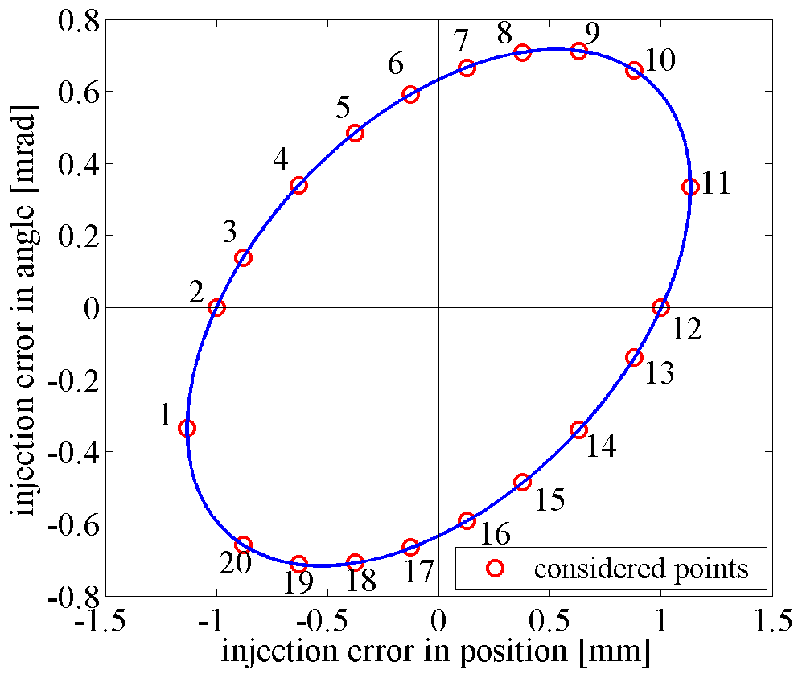

Fig. 8: Possible injection errors in the horizontal input phase space.

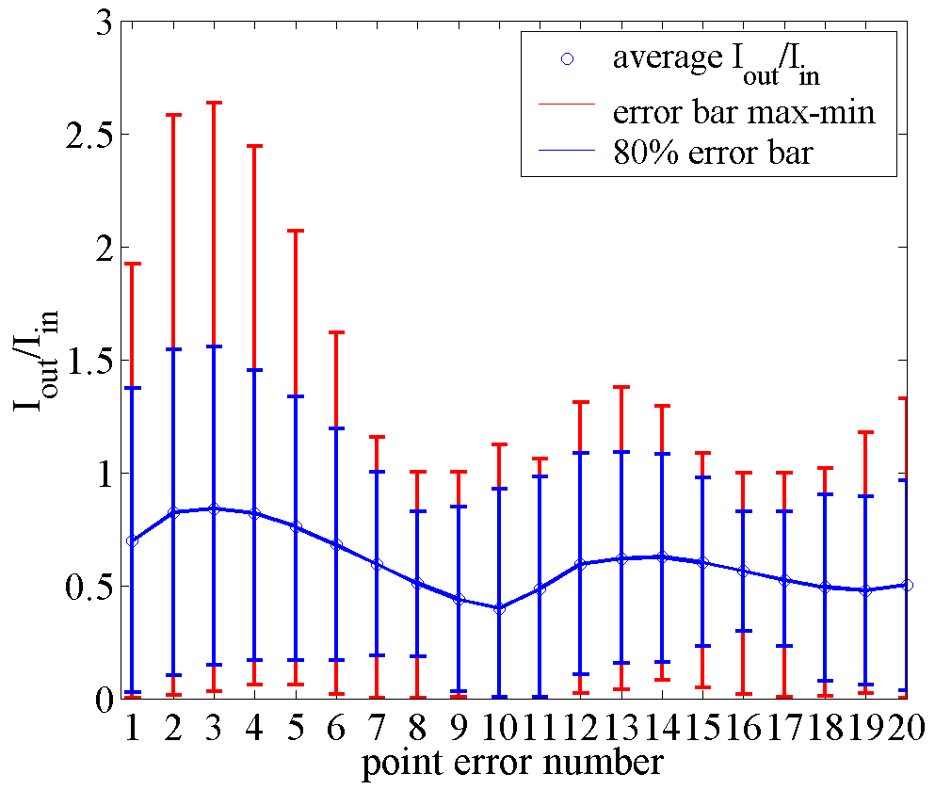

Fig. 9: Average invariant with the relative error bars for any possible injection error (I_{in}=0.716 mm mrad).

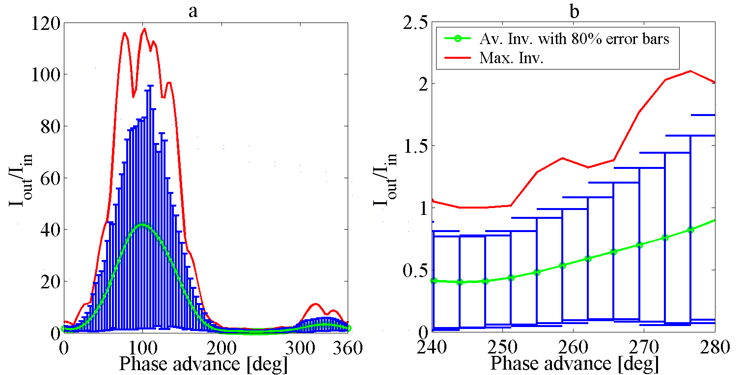

Fig. 10: Ratios I_{omax}/I_{in} and I_{oav}/I_{in} in the case of an injection error caused by a pure displacement of 1 mm for various values of the betatron phase advance.

- RF Deflector for CTF3 Delay Loop

3.1 Deflector design

The process of bunch train compression in the DL is illustrated in Fig. 11 and more detail can be found in [1].

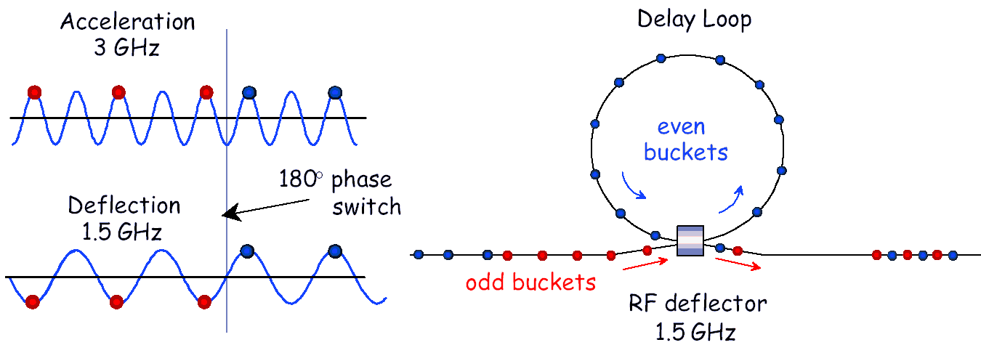
Fig. 11: Sketch of the bunch frequency multiplication in the CTF3 DL.

Even and odd trains are deflected by kicks of the same amplitude but opposite sign. Only the even trains are injected into the ring so they are delayed to interleave the following odd train.
The frequency of the Delay Loop deflector has to be half the linac frequency as described in fig 11. Other design parameters are the required deflecting angle, that is about 15 mrad, the maximum beam energy (300 MeV) and the RF power that the klystron can provide to the deflecting structure. The klystron is already available and its output power is 20 MW.
To match these specifications, a traveling wave type deflector should be about 1.5 meter long but this in not compatible with the available space. Therefore it is necessary to use a standing wave structure.

The major drawback of this choice is due to the fact that the voltage filling time of a resonant cavity is generally slow if compared to the RF pulse length (5$μs$). As a consequence the deflecting field is not constant during the passage of the train in the cavity and different bunches in the train see different kicks. In order to reduce this spread of deflection angle between the head and the tail of the train, the Q of the cavity has to be reduced and this can be done externally loading the resonator. The time domain response of the cavity to a step pulse of 5$μs$ is shown in fig. 12. The cavity Q is 3000. The length of the train of bunches is also indicated and the resulting voltage spread is less than 1%, that is considered an acceptable value. On the other hand it is not possible to further decrease the value of Q. Beyond a certain threshold the shunt impedance becomes too low and the field intensity in the cavity is no more sufficient to give the required angle to the beam.

train length
Fig. 12: cavity voltage as a function of time.

The cavity is externally coupled to a rectangular waveguide (WR650, the same standard of the klystron output) through a hole. The hole dimensions set the input coupling coefficient $β$ and have been chosen to have the wanted cavity loaded Q. In fig. 13 the model of the cavity coupled to the waveguide, used as input for HFSS simulations is shown. In fig 14 some results of simulations are summarized. In particular from the reflection and transmission frequency response it is possible to calculate respectively the coupling coefficient and the loaded Q.
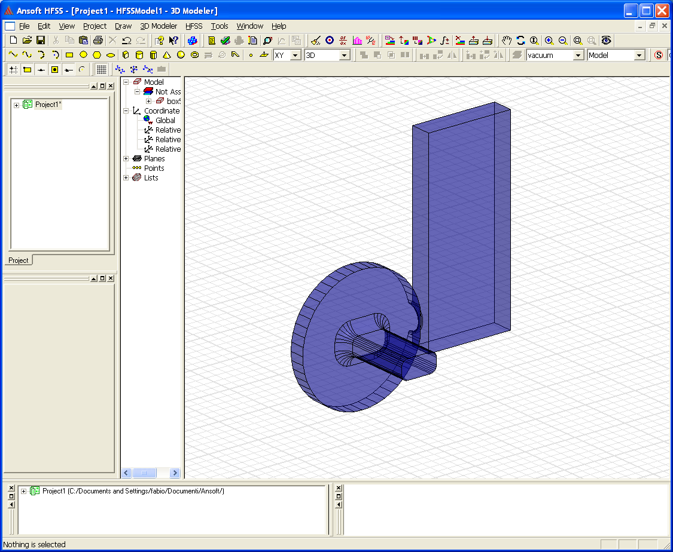

Fig. 13: HFSS simulations: the geometry of the loaded cavity.

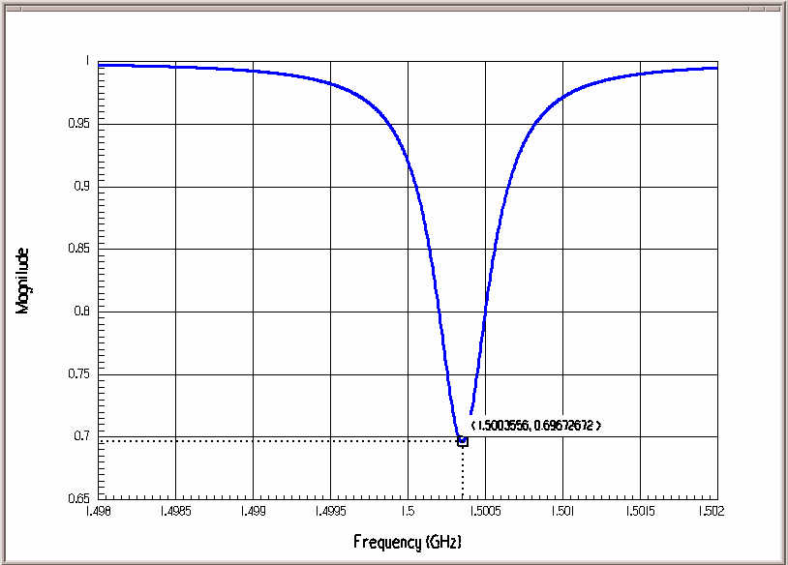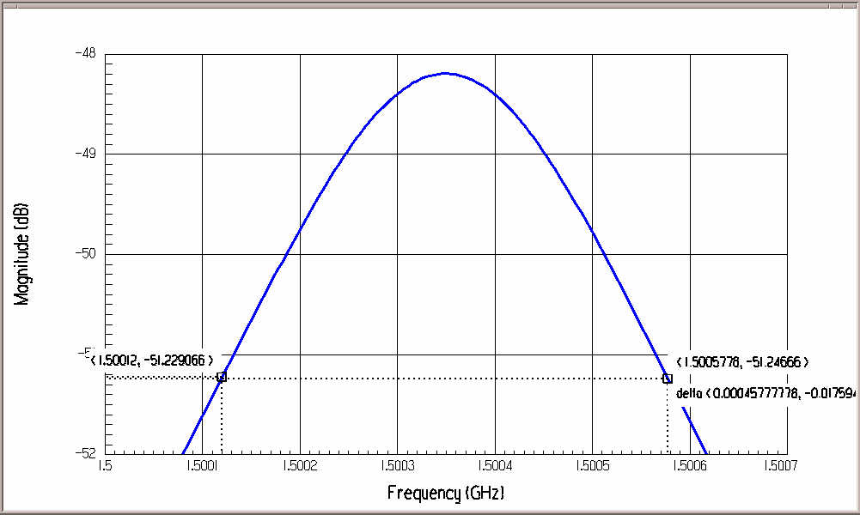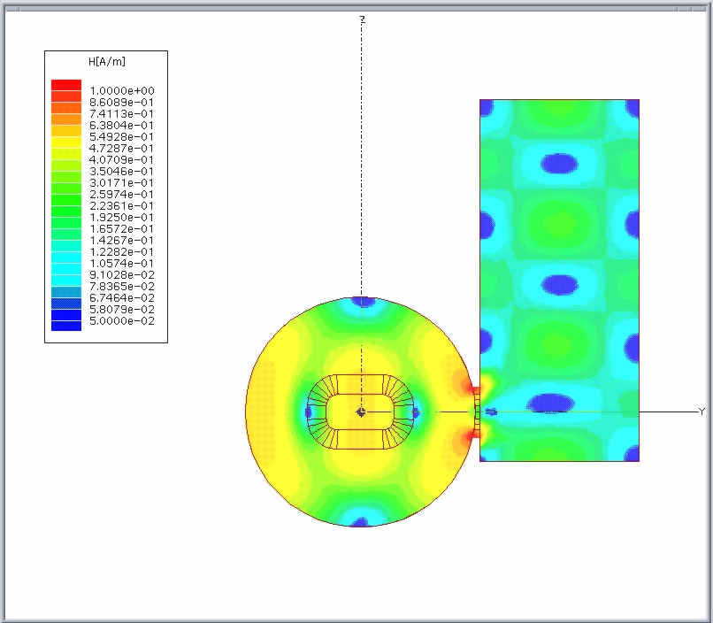
β=5.6
Q_{L}=3280

Fig. 14: simulations results. from left to right: reflection frequency response at the input port; bandwidth of the loaded cavity; amplitude of the magnetic field plotted on the transverse symmetry plane .

Another problem that arises with standing wave structure in this kind of utilization is due to the RF power reflected at the cavity input back to the klystron. The need to over-couple the cavity ($β$>1) implies that the reflection coefficient is different from zero. In the examined case with $β=5\text{.}6$ the reflection coefficient is $ρ$=0.7 i.e. the 49% of the incident power is reflected back.
Moreover, when used in pulsed regime, the level of the reflected RF is not a constant but presents a peak during the transient of negative slope. The height of this peak depends on the loaded Q of the cavity and on the pulse rise time.
Figure 15 shows the time dependence of the RF reflected power for two possible slopes of the input pulse. The more abrupt is the transient, the higher is the peak of the reflection.

Fig. 15: time domain cavity response to a step input. (Blue – RF input pulse. Red – cavity reflected power).

The klystron needs to be isolated respect to this reflected power and, according to a conventional scheme, described in fig 16 a), this is generally done by the use of a circulator.
Since the circulator is an expensive device, a different system has been thought, where the circulator has been replaced by a hybrid junction and two distinct cavities give the deflecting voltage to the beam (see fig.16 b)).
The hybrid splits the power coming from the klystron in equal parts at the two ports connected to the cavities. The phase relation between the voltages at these two ports is 90°, so the cavities are fed 90° out of phase each other. To sum up in phase the kicks delivered to the beam from the cavities they have to be placed an odd multiple integer of λ/4 of the RF wavelength apart along the beam line. For reasons of space the distance between the gaps has been chosen 250mm, i.e. 5/4λ_{RF}.
The power reflected by the cavities adds in phase at the fourth port of the hybrid where a load is connected, while it cancels out at the klystron port.
Although two ceramic windows are necessary in this scheme instead of one, they can be dimensioned to be able to support half of the RF power respect to the scheme on the left.

Fig. 16: (a): RF layout with circulator; (b): RF layout with hybrid.

The feasibility of this innovative solution has been checked by means of simulations with HFSS code. Fig.17 shows the full geometry used in the simulations. In fig. 18 are reported the results concerning the frequency response of the hybrid coupler. At the working frequency (1.4995 GHz) the phase difference between signals of the cavity side ports when the device is fed from klystron port is about 90°. The magnitude of cavity side port signals (green and red) are balanced. The reflected signal at klystron port (blue) is very low.
Finally fig.19 shows the results obtained for the frequency response of the whole system. The peak in transmission between klystron and load ports is due to the power dissipated into the structure, while the not completely flatness of the reflection response is probably caused by some small residual mismatch. However the effect of these mismatches is within the range of klystron acceptable reflected power.

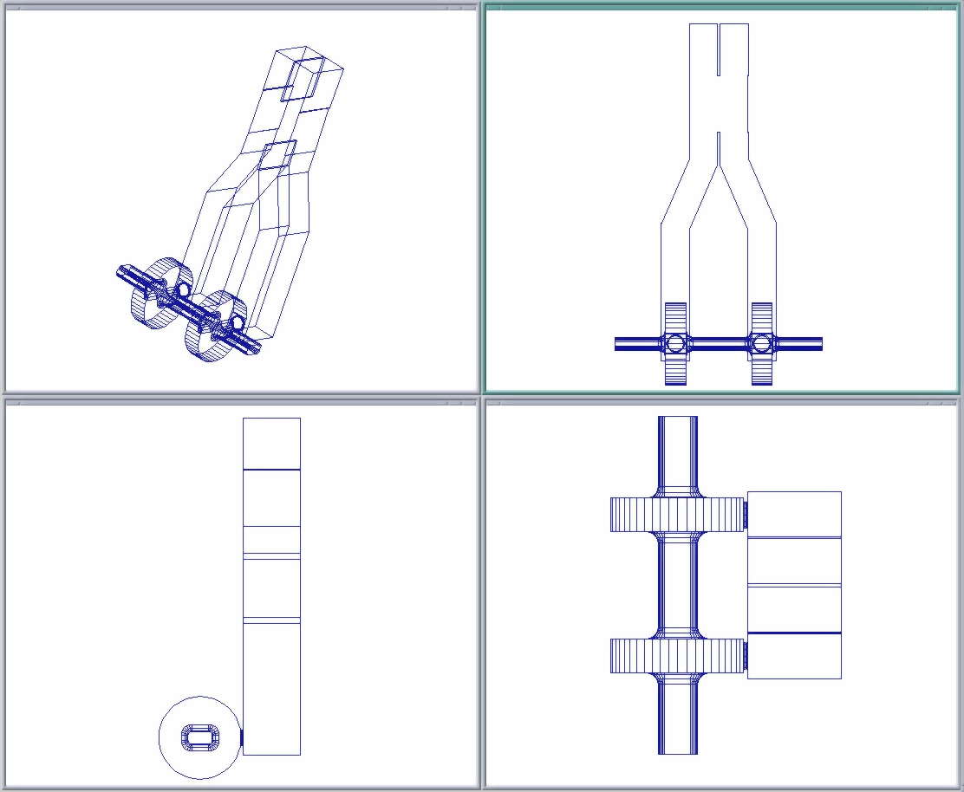

Fig. 17: input model for HFSS simulations.

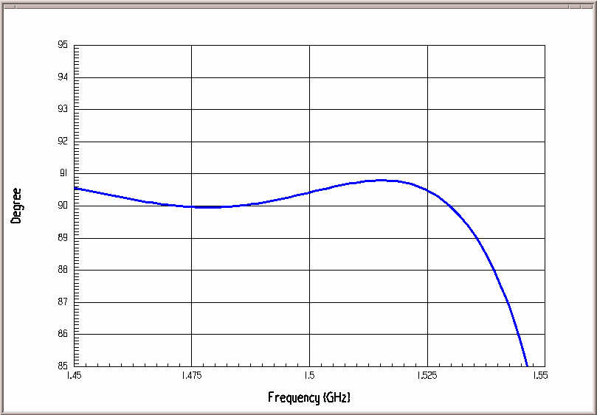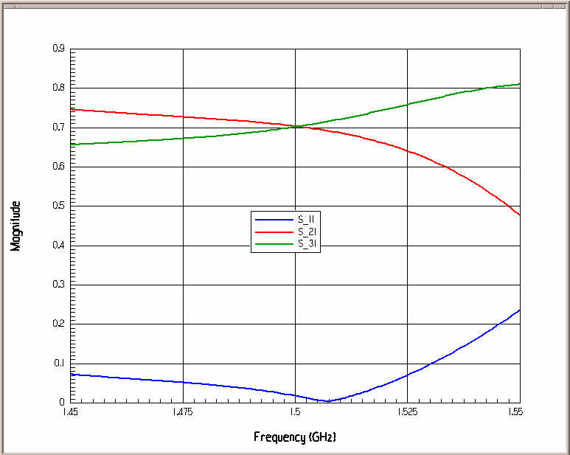

Fig. 18: phase difference between signals of the cavity side ports (left).
green and red: magnitude of cavity side port signals; blue: reflected signal at klystron port (right).

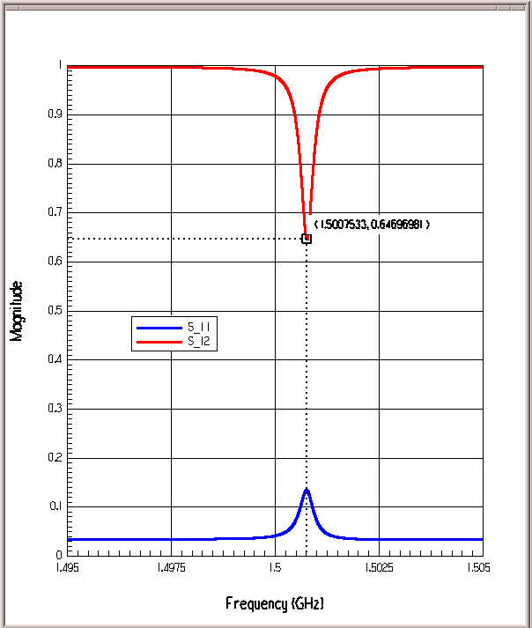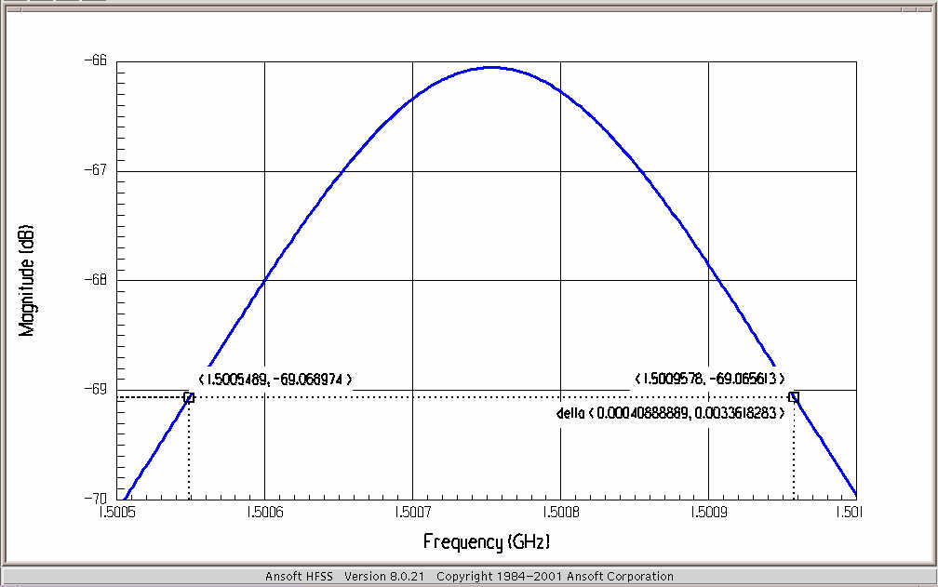

Fig. 19: blue: transmission between input and output port; red: reflection at the input port (left). bandwidth of the system (right).

3.2 Beam Loading in the RF Deflector of the CTF3 Delay Loop

Preliminary calculations of the effect on the transverse beam dynamics of the beam loading in RF deflectors have been done in [15] and will be completely presented in a forthcoming paper [16]. The general approach is to consider the single passage wake field generated by one bunch in the cavity(ies) and to develop a tracking code to study the multi-passage multi bunch effects. To do this it has been considered a general approach [17] for the single passage wake field. In particular Fig. 21 shows the different transverse wake field generated by the beam passage considering the different trajectories of Fig. 20. The wake field is perfectly out of phase only in the cases 1 and 3. Concerning the tracking code results, the most important conclusion is that, with the deflectors parameters of the previous paragraph the contribution in the emittance and position/angle growth of bunches can be considered a controllable effect.

Fig. 20: possible trajectories in the deflector.

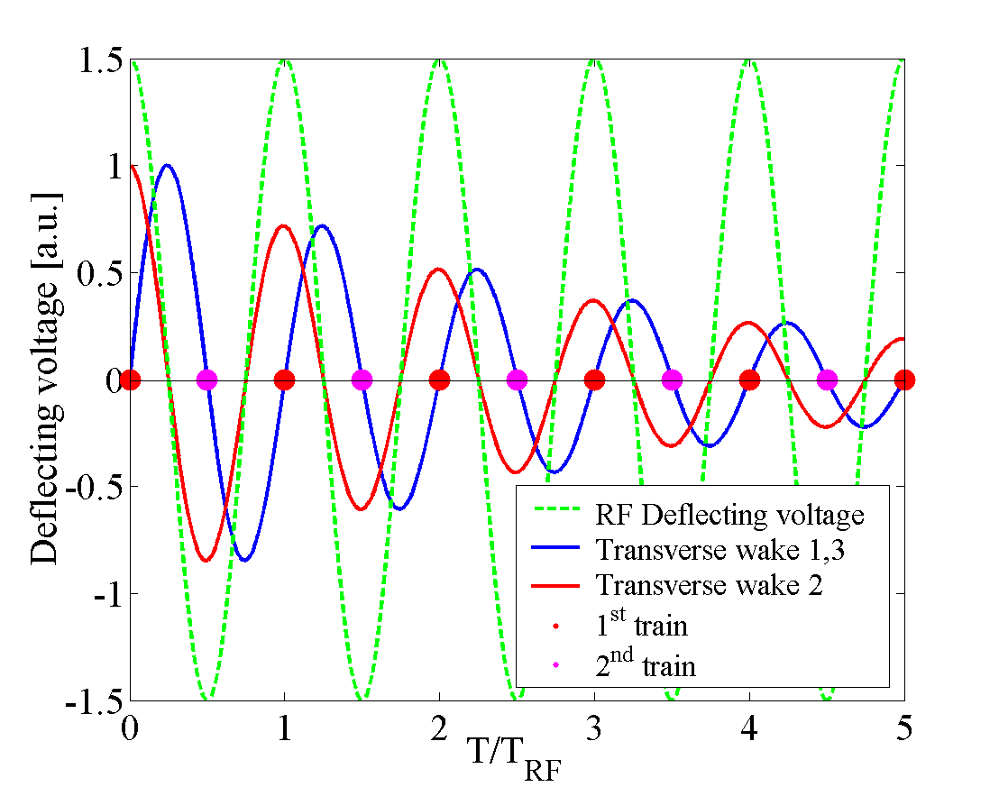

Fig. 21: Different transverse wakes generated by the bunch passage
with the trajectories of Fig. 20.

TESLA Damping Ring RF Deflectors

Recently, it hase been proposed a possible alternative injection/extraction scheme in TESLA Damping Ring (DR) using RF deflectors [18]. The idea to adopt, for the DR, an injection scheme similar to that of the Combiner Ring (CR) of CTF3 has been initially proposed by J.P. Delahaye [19]. The solution described below seems to be very promising from the point of view of required power and number of kickers.

4.1 Injection/extraction scheme using 2 or 3 frequencies

The direct way to apply the CTF3 injection scheme to the DR is to consider the Damping Ring itself as a Combiner Ring and to use 2 RF deflectors for the injection process and 2 for the extraction, as illustrated in Figs. 22 and 23. Fig. 24 shows the bunch distribution over the RF voltage. In the figure ${ΔT}_{L}$ is the time distance between bunches in the LINAC and ${ΔT}_{\text{DR}}$ is the time distance in the DR after the complete injection. The recombination factor indicates how much the bunches have been “compressed” in the DR with respect to their time distance in the LINAC.
Using the TESLA parameters [20] the requirements for the RF deflectors have been derived. The injection requirements for this scheme are listed in Table V.
It is important to remark that:
- the RF frequency of the deflectors can be chosen equal to the frequency of the LINAC in order to use the same type of klystrons;
- considering a reasonable value for ${Δφ}^{}$ equal to 0.6 mrad, the minimum deflecting angle to extract or inject the bunches is 12 mrad because ${Δφ}/{φ_{\text{MAX}}}=5\text{\%}$. This angle of deflection cannot be achieved of a reasonable length of the RF deflectors [21] (of the order of 1 m). To overcome such problem it is possible to use more frequencies in the inj./extr. processes;
- assuming a recombination factor F=20 the time distance between the bunches in the DR is 16.85 ns. Since the filling time of the RF deflectors should be less than ${ΔT}_{\text{DR}}$ it is necessary to use fast TW RF deflectors (as those of CTF3). Even with this type of deflectors it is necessary to introduce a gap in the DR filling pattern. In fact, typical filling times for TW RF deflectors are of the order of 100 ns. The gap in the DR filling pattern can be obtained with the method illustrated in Fig. 25. If the n_{B} bucket over N_{B}/F of the total train coming from the LINAC are empty, the total time gap is $T_{G}={ΔT}_{L}∗n_{B}$. With the typical filling times of TW deflectors it is enough to choose n_{B}=1, it means an empty bucket over N_{B}/F.

Table V - TESLA parameters in the inj./extr. processes using RF deflectors
 | QUANTITY | SYMBOL | VALUE
LINAC | Number of bunches in the Linac | N_{B} | 2820
LINAC | Bunch time spacing in the Linac | $${ΔT}_{L}$$ | 337 ns
LINAC | Bunch spacing | $${ΔL}_{L}={ΔT}_{L}∗c$$ | ~101 m
LINAC | Total length of the bunch train | $$L_{B}=N_{B}∗{ΔL}_{L}$$ | ~285 km
LINAC | Energy at the injection of the DR | E | 5 GeV
DR | Recombination factor | F | 20
DR | Total length of the DR | $$L_{\text{DR}}={L_{B}}/F±{{ΔL}_{L}}/F$$ | ~14 km
DR | Bunch spacing in the DR | $${ΔL}_{\text{DR}}={{ΔL}_{L}}/F$$ | ~5 m
DR | Bunch time spacing in the DR | $${ΔT}_{\text{DR}}={{ΔT}_{L}}/F$$ | 16.85 ns
DR | Emittance at extraction | $$ε$$ | 8.10⁻⁴ mm.mrad
DR | $β$ at the RF deflectors | $$β_{\text{Defl}\text{.}}$$ | 50 m
DR | $β$ at the septum | $$β_{\text{Sept}\text{.}\text{.}}$$ | 50 m
DR | $α$ at the RF deflectors | $$α_{\text{Defl}\text{.}}$$ | 0
DR | $α$ at the septum | $$α_{\text{Sept}\text{.}\text{.}}$$ | 0
RF DEFL. | Total number of RF deflectors | N_{D} | 4  (2 for inj. and 2 for extr.)
RF DEFL. | Freq. of the RF deflectors | f_{RF}= n*$1/{{ΔT}_{L}}$ | ~1.3 GHz (= 438*1/ DTL)
RF DEFL. | Deflection between the extr./inj. bunches and the stored ones | $${Δφ}^{}$$ | 0.6 mrad
RF DEFL. | Deflection of the extr./inj. Bunches | $$φ_{\text{MAX}}={Δφ}/1−\text{cos}\left(2π/F\right)$$ | 12 mrad!!

Fig. 22: CTF3-like injection scheme for the TESLA DR

Fig. 23: CTF3-like extraction scheme for the TESLA DR

Fig. 24: Bunch distributions over the RF voltage
in the CTF3-like inj./extr. scheme for DR

Fig. 25: Method to obtain a gap in the DR filling pattern

By using the combination of 2 or more frequencies it is possible to increase the ratio ${Δφ}/{φ_{\text{MAX}}}$ and, therefore, to reduce the maximum deflection.
With 2 different frequencies the maximum achievable ${Δφ}/{φ_{\text{MAX}}}$ is 44%. The deflection received by each bunch for a recombination factor F=20 is shown in Fig. 26. The TW RF deflectors parameters, relative to this case, are reported in Table VI. In this scheme it is necessary to use 4 RF deflectors for injection and 4 RF deflectors for the extraction. The total deflection is 1.36 mrad (0.68 mrad each deflector) to obtain $Δφ=0\text{.}6\text{mrad}$. The calculated length and filling times are referred to two possible input powers of 9 or 5 MW.
The use of two close frequencies can be interesting to feed a single RF device with the two frequencies. Looking at the typical dispersion curve of a TW RF deflector (Fig. 27) we can excite the structure at a frequency (f₁) near f*. Doing this we loose synchronism with the bunch but it is still possible to inject or extract the bunches in the damping ring [21].
Similarly with 3 different frequencies the maximum ${Δφ}/{φ_{\text{MAX}}}$ is equal to 69% and it is, obviously, better than the previous 2 frequencies case.
This kind of calculations can be performed considering different recombination factors F and comparing the various cases 2/3 distant/close frequencies as shown in Fig. 28. As predictable, the best results can be obtained considering 3 distant frequencies.

Table VI - RF deflectors parameters in the 2 frequencies case
P_{RF} [MW] | Number of deflectors | fRF [GHz] | Length [m] | Filling time [ns] | Numb. Of cells | Deflection [mrad] | $${Δφ}/{φ_{\text{MAX}}}$$
9 | 4 inj. +4 extr. | f_{RF1}=1281.90  f_{RF2}=1278.93 | 1.51 | 112 | 26 | $$\begin{aligned}φ_{\text{DEFL}1}=0\text{.}\text{68} \\ φ_{\text{DEFL}2}=0\text{.}\text{68}\end{aligned}$$ | 44%
5 | 4 inj. +4 extr. | f_{RF1}=1281.90  f_{RF2}=1278.93 | 2.03 | 150 | 35 |  | 44%

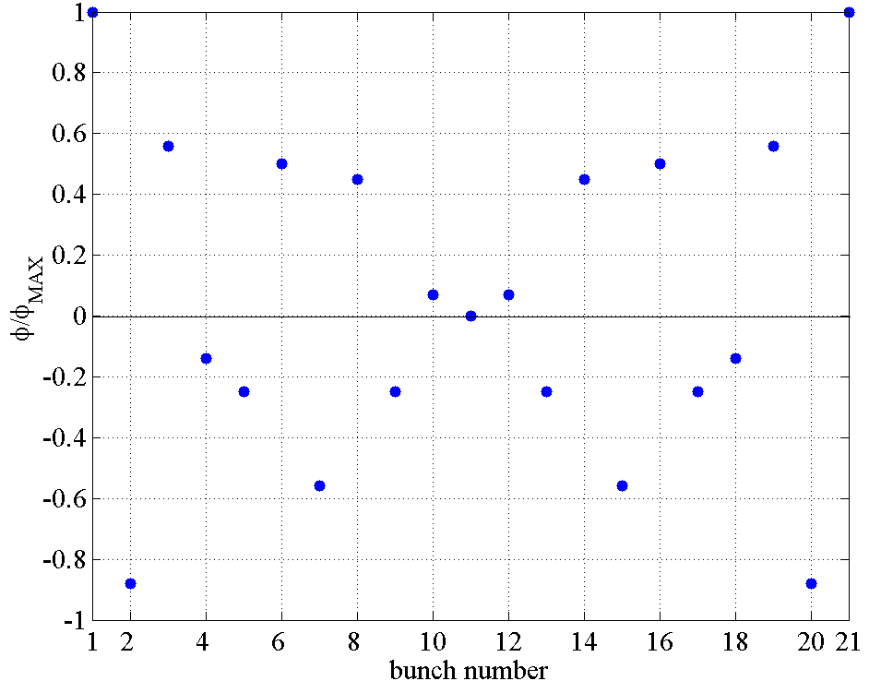${Δφ}/{φ_{\text{MAX}}}$

Fig. 26: Deflection of the bunches with 2 RF frequencies (${Δφ}/{φ_{\text{MAX}}}=\text{44}\text{\%}$)

Fig. 27: Typical dispersion curve of a TW RF deflector

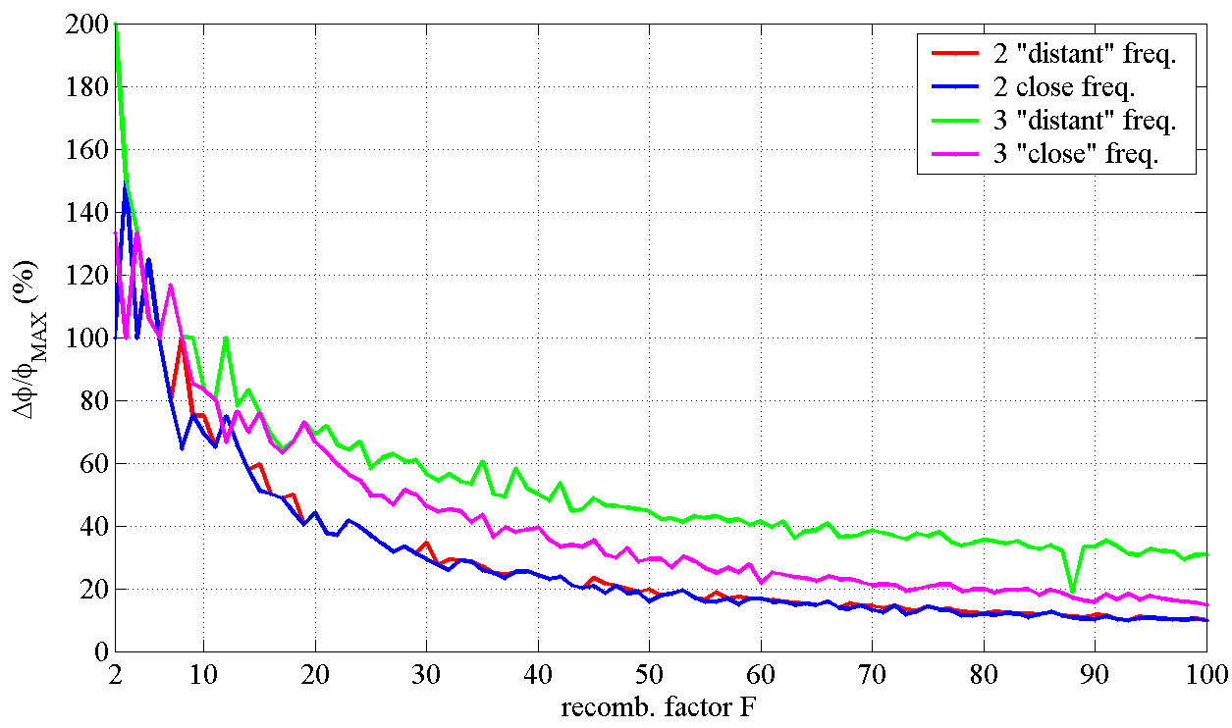
Fig. 28: ${Δφ}/{φ_{\text{MAX}}}$ considering different recombination factor F

In the optimization procedure it is important to consider the following other effects due to the longitudinal finite bunch profiles:
  - reduction of the${{Δφ}_{\text{TAIL}}}/{φ_{\text{MAX}}}$: this requires a different optimization procedure for the frequencies choice. In Fig. 29 it is shown, as example, the result of the optimization with 3 different frequencies;
  - effect of the RF finite wavelength that is especially harmful for the extracted bunches. In fact, for the injected ones, we expect a cancellation of this effect due to the damping mechanism. This requires a compensation with another RF deflector at the extraction to compensate the distortions due to the RF curvature over the extracted bunches (Fig. 30);
  - effect of the slope of the RF voltage over the stored bunches that is, in principle, canceled by the other deflector but that can cause problems if there are non linearities in the magnets between the two RF deflectors. Also in this case it is necessary an optimization procedure to reduce the RF slope over the bunch length.

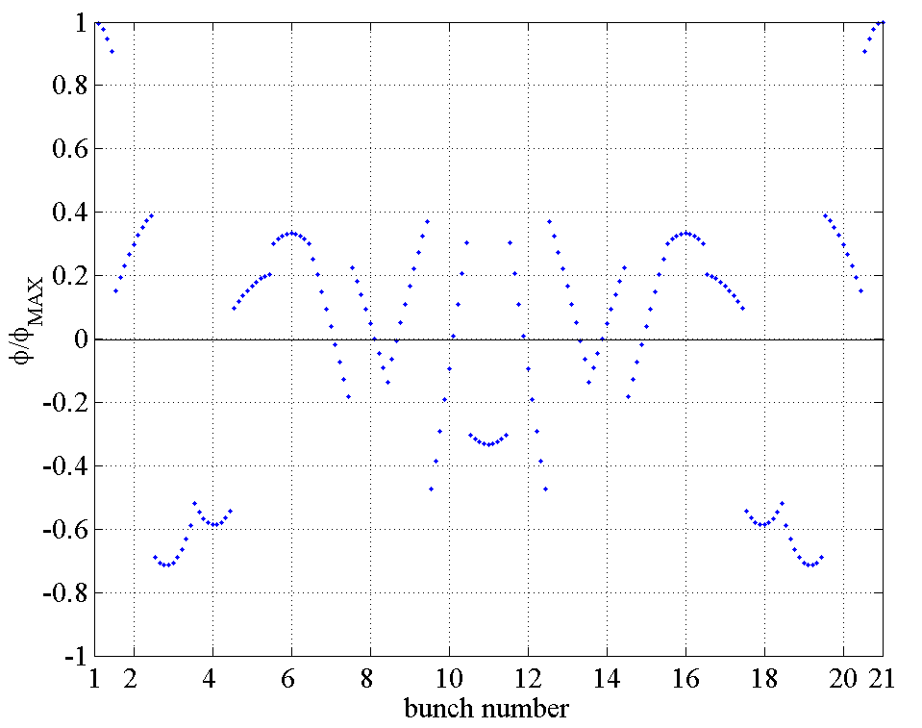
Fig. 29: Deflection of the bunches with 3 distant RF frequencies (${{Δφ}_{\text{TAIL}}}/{φ_{\text{MAX}}}=\text{57}\text{\%}$) for a gaussian bunch distribution ($σ_{z}=6\text{mm}$)

Fig. 30: Correction of the distortion due to the RF curvature over the extracted bunches

Recombination factor bigger than 20 have been also explored. As example, in Fig. 31 are reported the optimized solutions considering recombination factors F=45 and 3 frequencies. This case can be interesting considering recent calculations [22] to use the HERA Tunnel for the DR with a L_{DR}=6.3Km. In Table VII the possible RF deflector parameters are reported.

Table VII: RF deflector parameters in the 3 distant frequencies case assuming a gaussian bunch with $σ_{z}=6\text{mm}$ and F=45
P_{RF} [MW] | Number of deflectors | fRF [GHz] | Length [m] | Filling time [ns] | Numb. Of cells | Deflection [mrad] | $${Δφ}/{φ_{\text{MAX}}}$$
9 | 6 inj.+6 extr. | f_{RF1}=1326.41  f_{RF2}=1305.64  f_{RF3}=1299.70 | 1.50 | 111 | 26 | $$\begin{aligned}φ_{\text{DEFL}1}=0\text{.}\text{67} \\ φ_{\text{DEFL}2}=0\text{.}\text{67} \\ φ_{\text{DEFL}3}=0\text{.}\text{67}\end{aligned}$$ | 30%
5 | 6 inj.+6 extr. | f_{RF1}=1326.41  f_{RF2}=1305.64  f_{RF3}=1299.70 | 2.00 | 149 | 35 |  | 30%

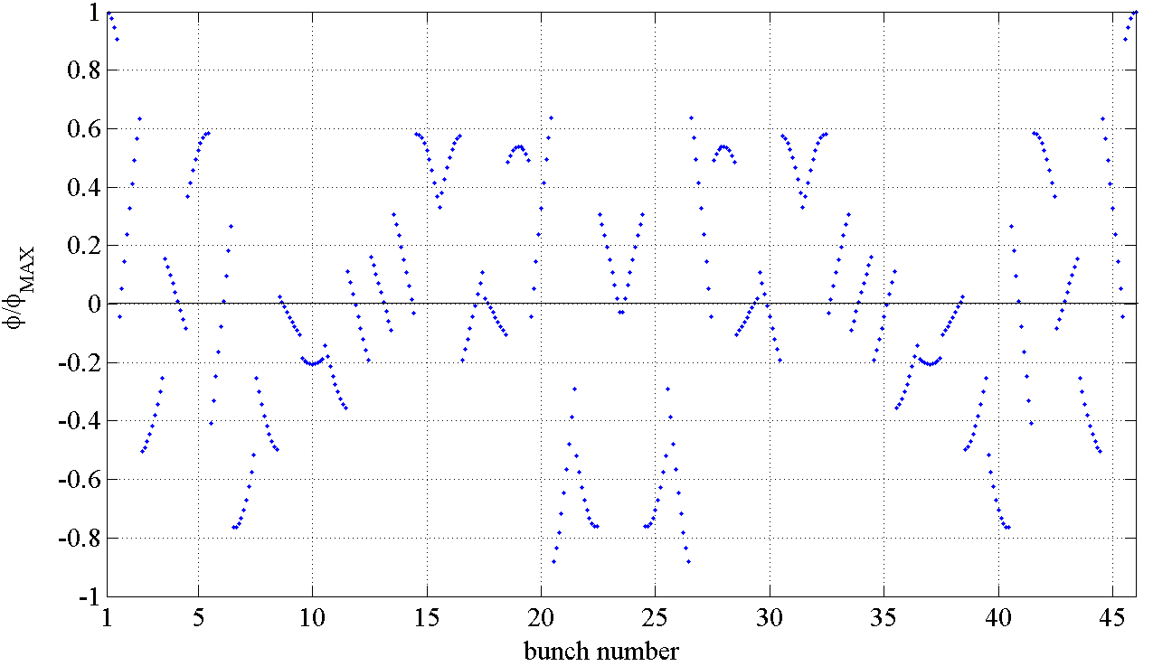

Fig. 31: Deflection of the bunches with 3 distant RF frequencies for a gaussian bunch distribution with $σ_{z}=6\text{mm}$ and F=45 (${{Δφ}_{\text{TAIL}}}/{φ_{\text{MAX}}}=\text{30}\text{\%}$)

The effects of errors have been also considered.
The possible main sources of errors in the inj./extr. processes are shown in Fig. 32. They are:

- the phase advance variation between the deflector 2 and 1 (Ph. Adv. 2-1) whose nominal value is $\text{180}°$;
- the RF amplitude and phase jitter of one of the deflectors group with respect to the other.

The Ph. Adv. 1-2 or the values of the optical functions $β,α$ in the deflectors can be considered as parameters that can magnify or reduce the effects of these errors.
All these errors are, obviously more critical in the extraction process since in the injection one they can be damped after some turns in the DR.
As example, the average and maximum values of the Courant-Snyder Invariants I_{out} divided by the nominal emittance $ε$ as a function of Ph. Adv. 1-2 and with Ph. Adv. 2-1=$\text{179}°$ are plotted in Fig. 33.

Fig. 32: Possible sources of errors in the extraction process
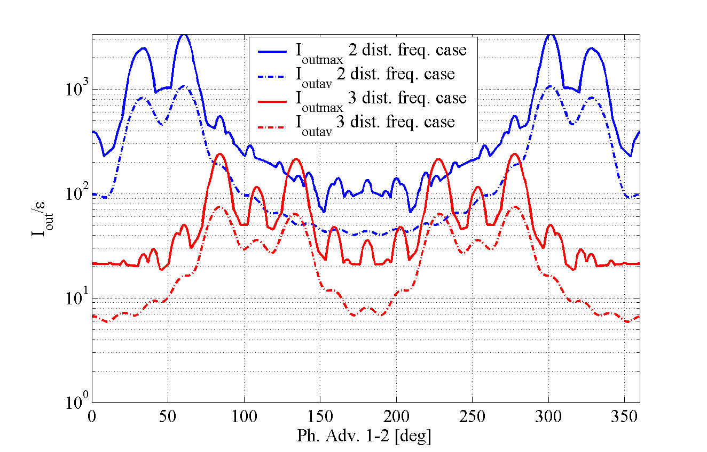

Fig. 33: Average and maximum values of the ratio I_{out}/$ε$ as a function of Ph. Adv. 1-2 and with Ph. Adv. 2-1=$\text{179}°$

4.2 RF deflector design considerations

Considerations concerning the design of RF Deflectors for TESLA Damping Ring are reported in [21]. Scaling laws have been applied to investigate the RF Deflector properties in term of length, filling time and dissipated power as a function of the iris diameter. Two optimized cells operating on the $π/3$ and $π/2$ modes have been investigated.
The RF deflectors characteristics of main interest for the DR are the filling time and the length of the structure. The shorter is the filling time, the smaller is number of empty bucket in the ring and the ring circumference itself, as a consequence. Minimizing the structure length and the filling time is important to reduce its beam coupling impedance and to maximize its efficiency in case of multi frequency excitation (see previous paragraph).
A typical dispersion curve of a Lengeler-type deflecting structure is plotted in Fig. 34. The three modes considered in the analysis are pointed out in the figure. The $π/2$ mode presents the highest group velocity v_{g} (highest tangent slope).

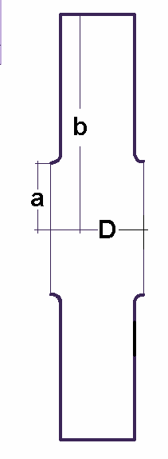
t/2

Fig. 34: Typical dispersion curve of a disk loaded structure (right) and single cell dimensional parameter (left)

The same kind of analysis done for CTF3 has been performed by scaling the Lengeler results at the frequency of 1.3 GHz. The choice of the 1.3 GHz derives from the availability of existing klystrons at this frequency.
For each considered mode we have fixed the energy of the beam (E=5 GeV), the angle of deflection (0.6 mrad) and the RF power feeding the structure (P_{RF}=9 MW and 5 MW) according to the calculations developed in [18].
The length of the structure (L) and the filling time ($τ_{f}$) are reported in Figs. 35 and 36 as a function of the iris radius (a).
Finally, it is pointed out in Fig. 37 the reduction of the effective kick when the deflector is fed by a 3 MHz detuned excitation. This happens when a double or triple frequency RF input feeds the same deflector. In the plots the thickness (t) of the iris is 11.53 mm.

Fig. 35: deflector length vs. iris radius (red: 9MW input power, blue: 5MW)

Fig. 36: deflector filling time (red: 9MW input power, blue: 5MW)

Fig. 37: relative reduction of the effective kick when the deflector is fed by a 3 MHz detuned excitation (red: 9MW input power, blue: 5MW)

For small values of a (low coupling between adjacent cells), the wave is backward and high shunt impedance can be obtained so the length of the deflector can be very short. On the contrary, the group velocity is very low and, consequently, the filling time is not the minimum possible. The group velocity reaches a maximum for a certain value of a and then decreases to zero (pure standing wave). Beyond this value the group velocity change its sign and the wave becomes forward. With a around 40 mm the filling time is minimized and the shunt impedance per unit length is high enough so that the desired deflecting field can be reached with a reasonably short structure.
Comparing the different modes results that the$π/2$ mode has suitable characteristics for our requirements. A second cell, designed to work in the $π/3$ mode, has been simulated as well, in order to explore the region on the left of $π/2$ in the dispersion diagram and because from that diagram also $π/3$ mode seems to have high group velocity.
The dimensions of the simulated cell for both the considered modes are listed in Table VIII (t=11.53 mm). The corresponding parameters are reported in Table IX.

Table VIII - dimensions of the cells for the $π/2$ and $π/3$ mode

Table IX: Single cell parameters from simulation results
mode |  |  |  | $π/2$ (f≈1.3GHz) |  | $π/3$ (f≈1.3GHz)
code |  |  |  | HFSS | MAFIA | HFSS | MAFIA
Series impedance |  |  |  | 0.578 | 0.552 | 0.608 | 0.618
Quality  Factor |  |  |  | 17000 | 17300 | 12400 | 12700
 |  |  |  | 16.07 | 15.95 | 12.03 | 11.97
Attenuation |  |  |  | 0.0180 | 0.0174 | 0.0254 | 0.026
Group velocity |  |  | $v_{g}$ | 0.045*c | 0.045*c | 0.043*c | 0.041*c

$E_{}$ = Equivalent deflecting voltage
P = RF power
p_{d} = rms dissipated power per unit length
w = rms stored energy per unit length

5 Conclusions

We have summarized different RF deflectors applications looking both at the design characteristics and at the effects on beam dynamics. In particular the CTF3 RF deflectors are traveling wave structures operating on the $2π/3$ mode. The electromagnetic project has been done scaling the Legeler-type deflectors and simulating the structure with the codes MAFIA and HFSS. The main effect on the beam dynamics is caused by out-of-phase wake generated by the off-axis passage of the beam and, in any case, it can be kept under control. The second RF deflector application is related to the CTF3 Delay Loop. The design based on the 2 standing wave cavities coupled with a hybrid junction has been illustrated and the effect on beam dynamics briefly discussed. Finally the applications of RF deflectors on the injection/extraction schemes of TESLA damping ring have been illustrated. The inj./extr. processes using TW RF deflectors is feasible and we have illustrated different possible solutions using 2 or 3 RF frequencies in 2, 4 or 6 RF deflector groups.

References

[1] “CTF3 Design Report”, CERN PS 2002-008 (RF), Geneve, (2002).

[2] see for example: P. Emma, et al., “A Transverse RF deflecting structure for bunch length and phase space diagnostics”, LCLS-TN-00-12, 2000; G.A. Loew, O,H Altenmueller, “Design and applications of RF deflecting structures at SLAC”, PUB-135, Aug. 1965 ; D. Alesini and C. Vaccarezza, SPARC Note, SPARC-BD-03/001, Frascati, November 2003

[3] The CLIC Study Team, Ed. G. Guignard, A 3 TeV e⁺e⁻ Linear Collider Based on CLIC technology, Report CERN 2000-008 (July 2000), http://preprints.cern.ch/yellowrep/2000/2000-008/p1.pdf.

[4] H. Braun, et al., “The CLIC RF Power Source: a Novel Scheme of Two-Beam Acceleration for Electron-Positron Linear Colliders “, CERN 99-06, Geneve, (1999).

[5] H. Braun, “A new Method of RF Power Generation for Two-Beam Linear Colliders”, CERN/PS/98-14 (LP), Geneve, (1998).

[6] C. Milardi, D. Alesini, et al., “CTF3 Compression System”, Proc. of the 2002 European Particle Accelerator Conference, Paris, (EPS-IGA/CERN, Geneva, 2002).

[7] D. Alesini, et al., “The RF Deflectors for CTF3”, CTFF3 Technical Note, INFN-LNF Accelerator Division, LNF Frascati, (2001).

[8] D. Alesini, et al.,”RF Beam Deflectors for CTF3 Combiner Ring”, Proc. of the 2002 European Particle Accelerator Conference, Paris, (EPS-IGA/CERN, Geneva, 2002).

[9] R. Corsini, et al.,”Report on the Third Operation of the CTF3 Preliminary Phase in 2002, 16 Sept.-25 Oct.”, CTF3 Note 054 (MD), Geneva, (2003).

[10] R. Corsini, A. Ferrari, L. Rinolfi, P. Royer, and F. Tecker, Phys. Rev. ST Accel. Beams 7, 040101 (2004);

[11] P. Bernard, et al., “On the design of disc-loaded waveguides for RF separators”, CERN 68-30, (1968).

[12] Y. Garault, “Etude d´une classe d´ondes électromagnétiques guidées : les ondes EH; application aux structures déflectrices pour les séparateurs à onde progressive de particules relativists”, CERN 64-43, (1964).

[13] http://www.cst.de

[14] D. Alesini and A. Gallo, Phys. Rev. ST Accel. Beams 7, 059901 (2004)

[15] Eighth CLIC/CTF3 Collaboration Meeting, D. Alesini, “Effect of the beam loading in the DL RF deflectors”, http://ctf3.home.cern.ch/ctf3/New_collab_meet.htm.

[16] D. Alesini and F. Marcellini, EPAC 2004.

[17] G. Dôme, “RF Theory”, CERN 92-03, Vol. I, Geneve 1992.

[18] D, Alesini et al., TESLA Report 2003-26, 2003.

[19] J.P. Delahaye, TESLA 93-02, 1993.

[20] TESLA Technical Design Report, Desy, 2001.

[21] D, Alesini et al., TESLA Report 2003-27, 2003.

[22] W. Decking, “A TESLA Damping Ring in the HERA tunnel”, Tesla Collaboration meeting, 22-24/01/2003,Desy.

9 MW is the maximum output power of the klystrons developed for TESLA.

